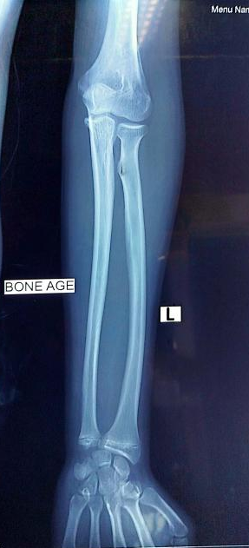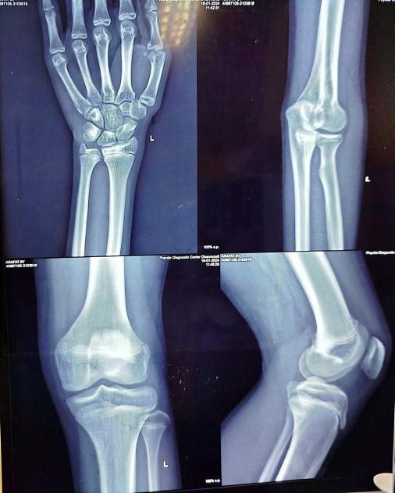

Figure-2b: Bone age (16-17 years) after hydrocortisone replacement
Figure-2a: Bone age (10-12 years) before
starting treatment

