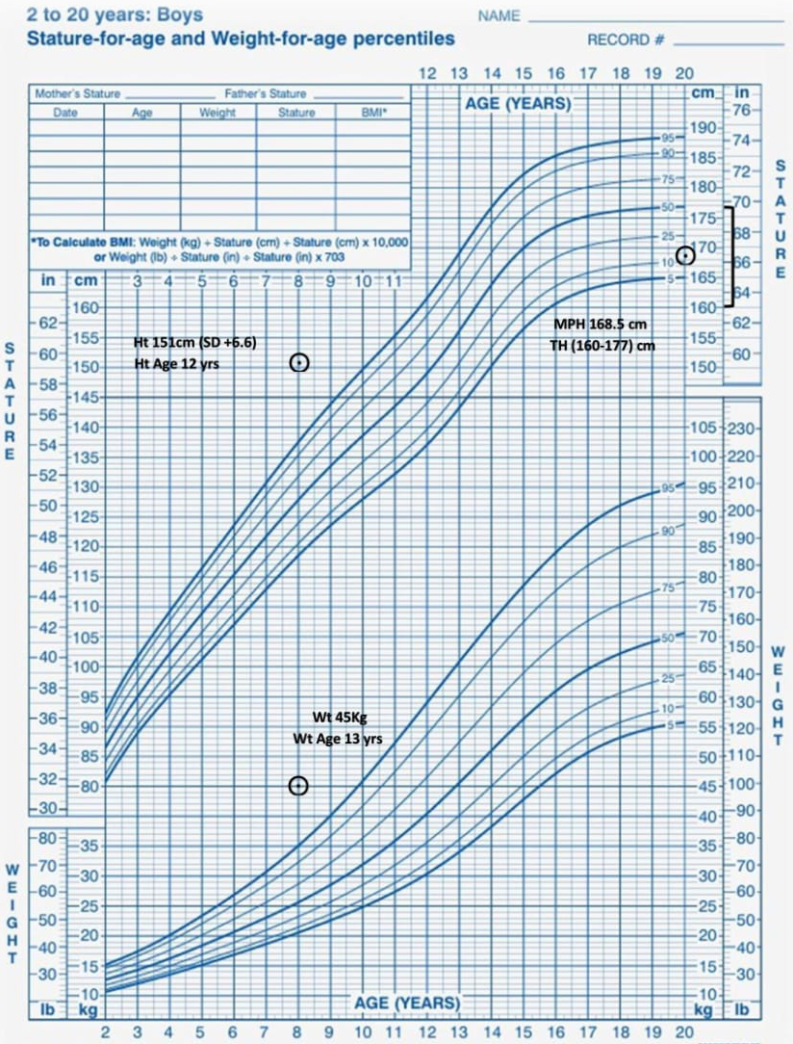
Figure-1: Anthropometric measurements of the patient

