Affiliation and address of Authors
1.Dr. Suchibrata Das, (Corresponding author)
Assistant Professor,
Department of Dermatology, Venereology and Leprosy,NRS Medical College
138 AJC Bose Road, Kolkata 700014, West Bengal, India.
e-mail – suchibratadas@yahoo.com , mobile -+91-9433203128
2. Dr. Joyeeta Chowdhury, Assistant Professor, Department of Dermatology, Venereology and Leprosy,NRS Medical College, 138 AJC Bose Road, Kolkata 700014, West Bengal, India.
3. Dr Sangita Patra, RMO Cum Clinical tutor, Department of Gynaecology and Obstetrics, Medical College and Hospital, Kolkata, 88, College Street, Kolkata 700012. West Bengal, India. 4. Dr. Arun Achar, Associate Professor, Department of Dermatology, Venereology and Leprosy, NRS Medical College, 138 AJC Bose Road, Kolkata 700014, West Bengal, India.
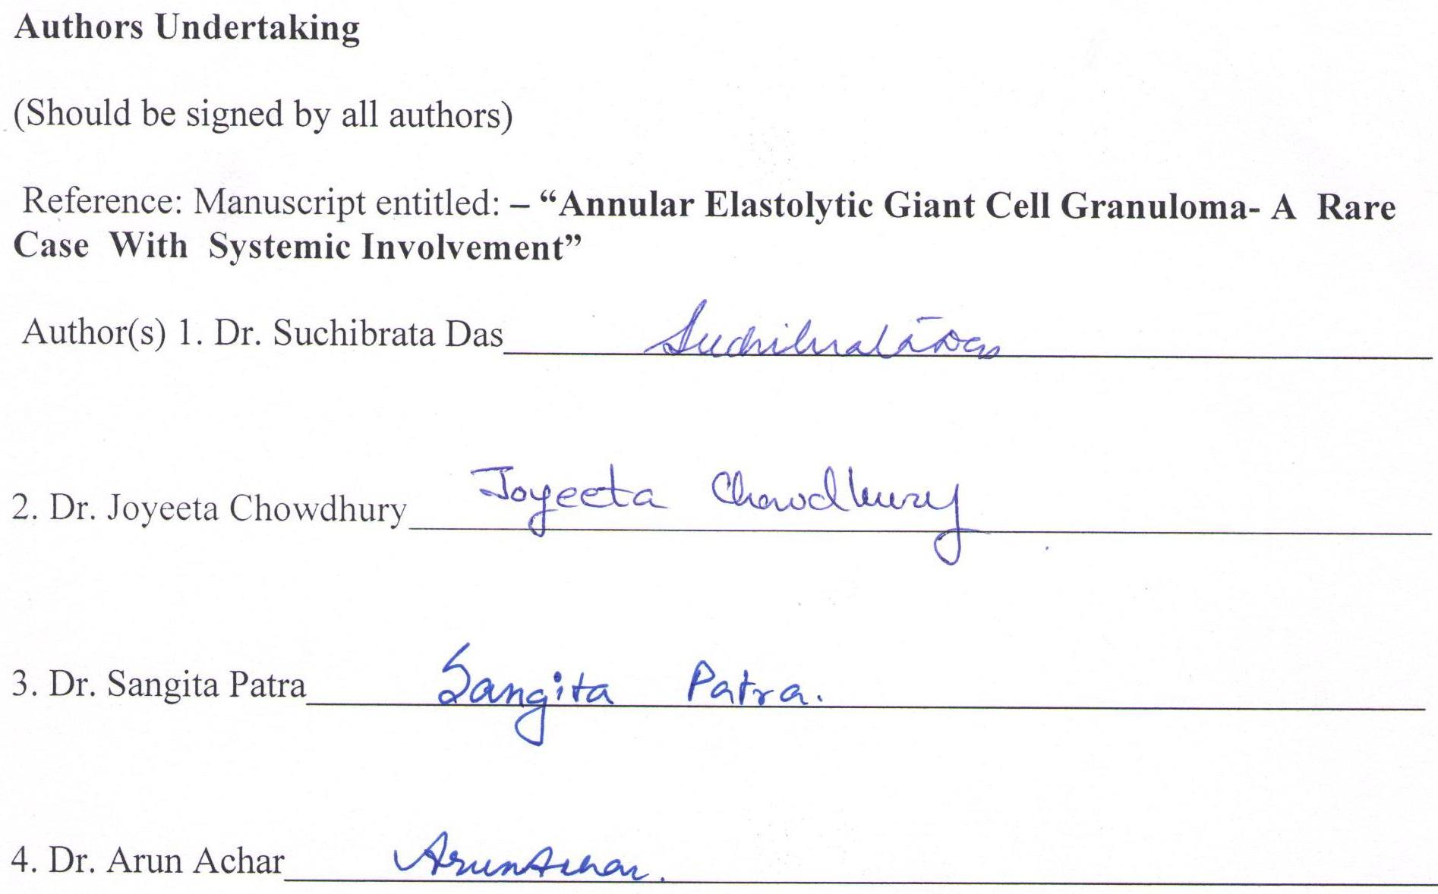
Submitted for publication in the journal:
BANGLADESH JOURNAL OF MEDICAL SCIENCE
Conditions of Submission:
Ownership Rights: All proprietary rights other than copyright (such as patient rights) are reserved to the authors, this include the right to reproduce original figures and tables from this item in their future works, provided full credit is given to the original publication.
Originality: The authors assures that this submission is an original work and that neither this work nor one with substantially similar content has been published elsewhere in whole or in part (except in abstract form), that it has only been submitted for this publication, and that it will not be submitted elsewhere pending written notice of acceptance or rejection by this journal (Please express explicitly if you have the plan to publish any more article based on partial data of this work).
Declaration of authorship: The undersigned certify that all authors have participated sufficiently in the conception and design of this work and the analysis of the data (when applicable), as well as the writing of the manuscript to take public responsibility for it. The undersigned believe the manuscript represents valid work and have reviewed the final version of the manuscript and approve it for publication.
Data availability: The undersigned attest that they shall produce the data upon which the manuscript is based for evaluation by the Editors of their assignees should it be requested.
Disclaimer: The undersigned assures that the manuscript contains no libelous or unlawful statements and does not infringe on the rights of others. If excerpts (text or artwork) from copyrighted works are included, written permission will be secured by the authors and proper credit will be shown in the manuscript.

