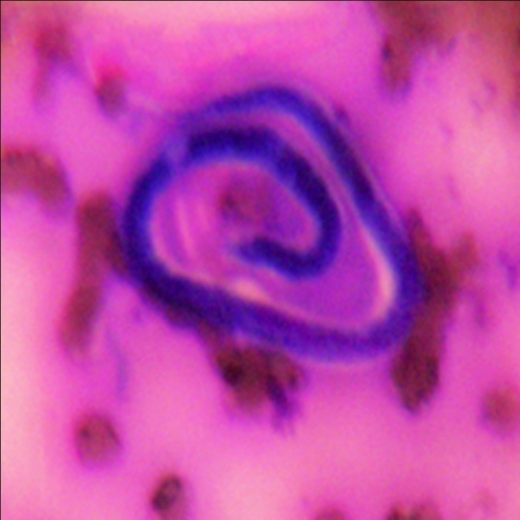

Fig.1 Photomicrograph showing single sheathed microfilaria bancrofti-the sheath is larger than body and tail tip is free of nuclei in the background of colloid ( Leishman-Giemsa stain, X400)

(SUPPLEMENTORY PHOTO NOT FOR PRINTING)

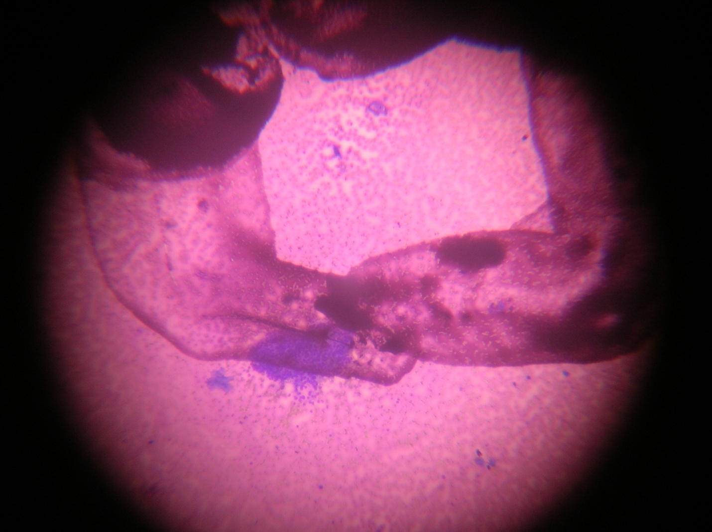

Smear shows presence of microfilarial larva with few mono-layered clusters of benign follicular cells in the background of blood mixed colloid . (Leishman-Giemsa stain. ×100)
(The parasite lying within the encircled area and follicular cells are lying in clusters near the
encircled area)

